Chapter 3 Radioactivity and radiation

Chapter Test Total marks 45

Name: Class: Date:

Section A (1 mark per question)

Select the best answer for each question.

Question 1

Beta-minus radiation is:

1. energy emitted from an electron of an atom
2. an electron ejected from an atom
3. a helium nucleus emitted from an atom
4. an electron emitted from the nucleus of an atom

Question 2

Which of the following travels at the greatest speed?

1. gamma radiation
2. beta radiation
3. alpha radiation
4. They all have the same speed.

Question 3

The heaviest form of radiation is:

1. gamma
2. beta-minus
3. alpha
4. none of the above

Question 4

The type of radiation that is most ionising is:

1. gamma
2. beta
3. alpha
4. none of the above

Question 5

The most penetrating form of radiation is:

1. gamma
2. beta
3. alpha
4. none of the above

Question 6

The type of radiation we are exposed to from the Sun is:

1. gamma
2. beta
3. alpha
4. none of the above

Question 7

The value of *x* in the decay equation:  is:

1. 238
2. 236
3. 234
4. 232

Questions 8 and 9 refer to the following information.

Strontium-90 is one of the radioisotopes that was released during the Fukushima nuclear disaster in Japan. Strontium-90 has a half-life of 28.8 years.

Question 8

How many neutrons are there in each nucleus of Sr-90?

1. 90
2. 38
3. 128
4. 52

Question 9

If 1.8 × 1010 atoms of Sr-90 were released during the accident, how many of the original Sr-90 nuclides will still be in existence in 144 years?

1. none
2. 3.6 × 109
3. 2.8 × 108
4. 5.6 × 108

Question 10

A radioactive sample of oxygen-15 has a half-life of 110 minutes. If the amount remaining after 5.5 h is 0.80 g, the original sample had a mass of:

1. 2.4 g
2. 2.8 g
3. 6.4 g
4. 9.6 g

Section B

Question 1

Complete the following decay equations by replacing :

**a.**  (1 mark)

**b.**  (1 mark)

**c.**  (1 mark)

Question 2

When bombarded with neutrons, gold (Au-197) undergoes neutron absorption to become the radioactive isotope gold-198. Given that gold has an atomic number of 79, write a balanced equation for:

**a.** the absorption of a neutron by a gold-197 atom (2 marks)

**b.** the beta decay of a radioactive nucleus of gold-198. (2 marks)

Question 3

Cobalt-60 has a half-life of 5.3 years. A sample of pure cobalt-60 has a mass of 50 µg. How much of the Co-60 remains after:

**a.** 10.6 years? (2 marks)

**b.** 15.9 years? (2 marks)

**c.** 21.2 years? (3 marks)

Question 4

Why is alpha radiation not used as a source in external radiotherapy treatment? (2 marks)

Question 5

A 78 kg man is exposed to 200 mJ of gamma radiation. Calculate:

**a.** his absorbed dose (1 mark)

**b.** his dose equivalent (1 mark)

**c.** his dose equivalent if he had been exposed to 200 mJ of alpha radiation instead (1 mark)

**d.** the energy of the radiation in electronvolts (eV). (1 mark)

Question 6

As a doctor you prescribe a course of radiotherapy for a patient with breast cancer. The procedure involves inserting a radioactive source into the affected region. Explain which type of radiation source—alpha, beta-minus or gamma—you would prefer to use and why. (4 marks)

Question 7

A scientist uses a Geiger counter to measure the radiation of a radioactive sample. She records the count as 60 000 emissions per minute.

**a.** Calculate the activity of the sample in becquerel (Bq). (1 mark)

**b.** It takes 1.5 hours for a 100 µg sample of the radioisotope to decay to 25 µg.   
Calculate the half-life of the sample in minutes. (3 marks)

Question 8

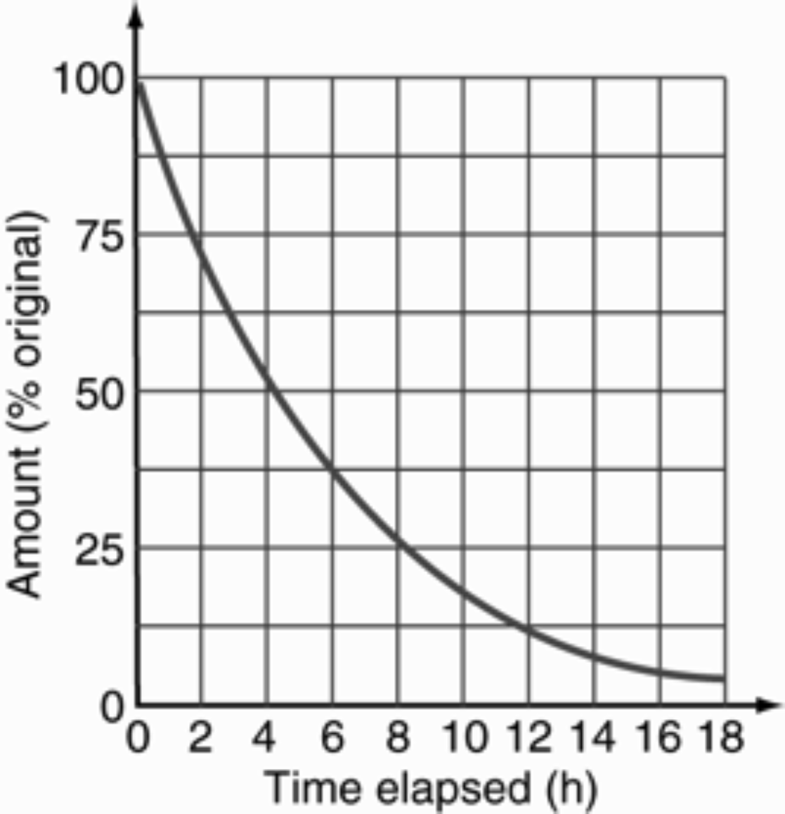The radioactive decay of a particular isotope is shown on the graph below. The initial mass of the radioisotope is 20 g.

**a.** Find the time it takes for a 20 g sample to decay to 5.0 g. (2 marks)

**b.** Find the half-life of the sample. (1 marks)

**c.** How much of the original radioisotope (in grams) remains after 6.0 hours? (2 marks)

**d.** Calculate the amount of the radioisotope remaining (in grams) after 20 hours have elapsed.

(2 marks)